GenAI Testing

Various models of genai
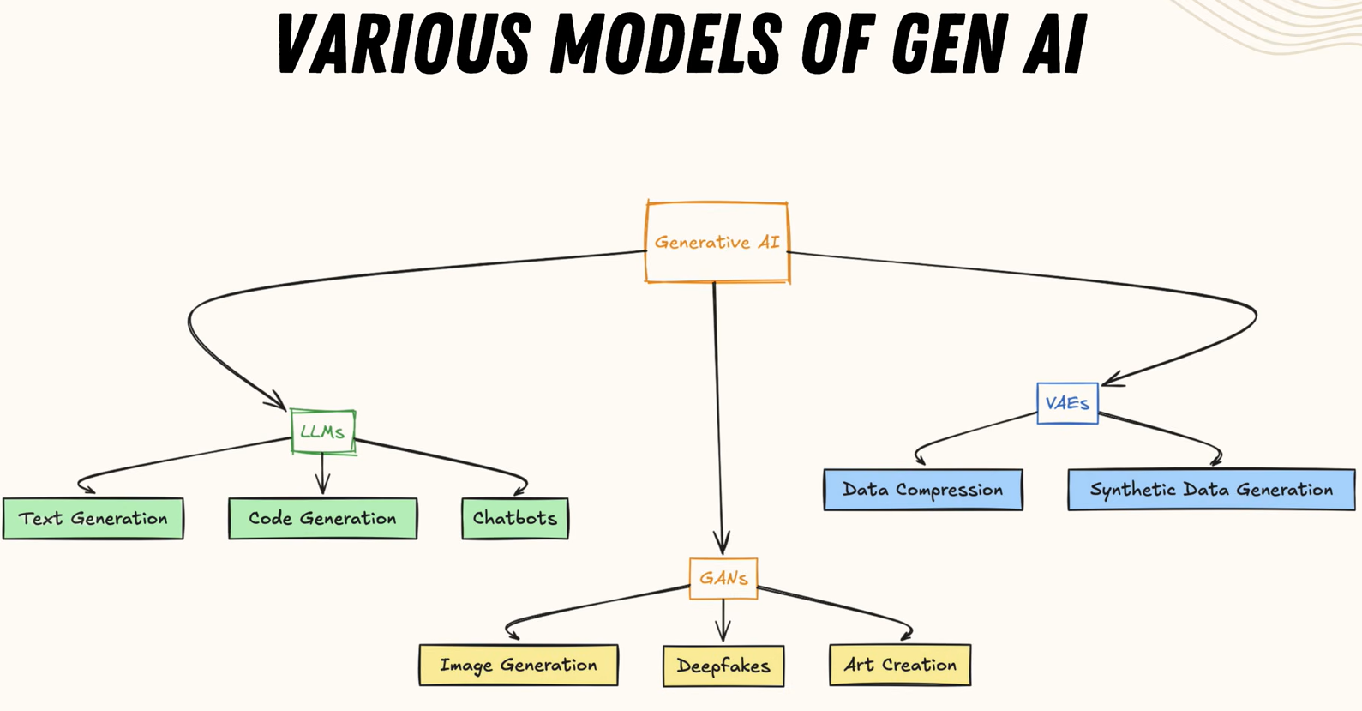
- Large Langauge Model (LLM)
- Variational Autoencoder (VAE)
- Generative Adversarial Network

Applications of software testing with genai
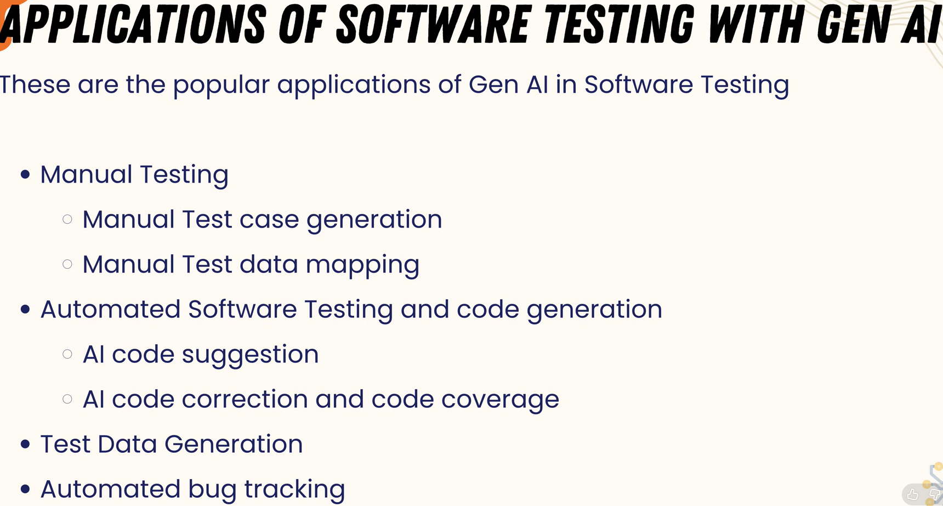

How companies use LLM’s ?
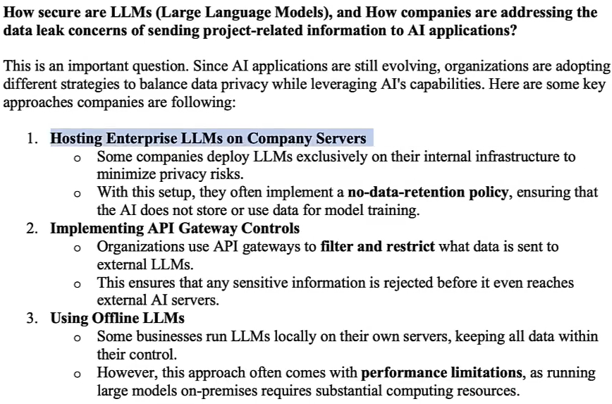

There Are 3 Ways GenAI Is Implemented in Testing

1. AI as an Assistant (Most Common Today)
- This is NOT a framework.
- This is:
  - Using OpenAI / Gemini / Claude
  - Inside IDE
  - Inside CI
  - Inside custom scripts
- Example:
  - Developer writes Jira story
  - Script sends story to LLM API
  - LLM returns test cases
  - Developer reviews
  - Playwright executes
- Here, GenAI is integrated manually using API.
- No special “AI testing framework”.
- Just LLM + existing automation.
- AI-as-assistant does NOT automatically monitor your project.
- It works only when you:
  - Prompt it
  - Paste logs
  - Ask for fixes
  - Ask for new test generation

2. AI-Enhanced Testing Platforms (Actual Products)
- There ARE AI-based testing tools.
- AI is embedded inside the automation tool to improve reliability, maintenance, and stability — but humans still define what to test.
- Focus : Making automation smarter and more stable.
- Examples:
  - Mabl
  - Testim
  - Functionize
  - Applitools
- Primary Focus:
  - Record user flows
  - Use AI to generate locators
  - Self-heal broken selectors
  - Use ML for visual testing
  - Detect layout shifts
  - Reduce flaky failures
- Secondary Focus : generated test-cases and scripts, they can be llm/ human generated
- These are commercial AI-driven testing frameworks.
- Under the hood:
They still use browser automation engines.
- But they add AI layer on top.
- AI Layer
⬇
Playwright/Selenium (hidden internally)
⬇
Browser
- So here:
  - Playwright/Selenium = Engine
  - AI = Smart maintenance + self-healing layer

3. New GenAI-Native Tools (Emerging)
- AI-native tools use AI as the primary decision-maker for exploring, generating, and executing test scenarios — with minimal scripting — but still require human oversight.
- Some modern startups are building:
  - Natural language → test execution directly
  - AI agents that explore UI
  - Vision-based testing (like GPT + computer vision)
- These tools try to reduce scripting entirely.
- AI behaves like a tester
- You write:
  - "Test login with valid and invalid credentials"
- The system:
  - Opens browser
  - Detects input fields visually
  - Executes scenario
- Still early-stage but evolving fast.
- AI brain
⬇
Automation engine (like Playwright)
⬇
Browser

Summary
1. AI as Assistant
LLM helps humans generate test cases and scripts on demand.
Execution happens via Playwright/Selenium.
No built-in intelligence in automation tool.

2. AI-Enhanced Platform
Automation tool has built-in AI to improve stability, locator healing, visual testing, and flakiness detection.
Humans still define test coverage.

3. AI-Native Tool
AI actively explores the application, generates scenarios, and drives testing decisions with minimal scripting.
Human supervises rather than writes tests.

Some Important terms in gen-ai testing

1. Self-Healing Locators
Problem (Traditional Automation)
You write:
page.click("#login-btn-123")
Developer changes:
id="login-btn-789"
What is this?
Test fails.
Now multiply this across:
- 500 tests
- Weekly UI updates
AI-Enhanced Behavior
AI doesn’t store just:
#login-btn-123
It also stores:
- Button text (“Login”)
- Button role (button)
- Position on page
- Parent container
- Nearby labels
- Historical patterns
- DOM hierarchy
When ID changes:
AI says:
“This element changed, but I found a similar button with text ‘Login’ in the same location.”
Updates locator automatically.

2. Smart Element Detection
Traditional automation relies heavily on:
- ID
- XPath
- CSS selectors
But many modern apps:
- Generate dynamic IDs
- Use React components
- Change DOM frequently
AI-Enhanced Tool
Instead of fragile XPath: //div[3]/div[2]/button
AI understands semantic meaning:
- This is a “Submit Order” button
- Inside Checkout page
- Inside payment form
It prefers:
- Role-based locators
- Text-based locators
- Accessibility attributes

3. Flaky Test Reduction
What is a Flaky Test?
A test that:
- Passes sometimes
- Fails sometimes
- Without code change
Reasons:
- Timing issues
- Slow API
- Animations
- Race conditions
AI-Enhanced Tool
AI analyzes historical runs:
Example:
Test A failed 3 times.
All failures happened:
- When response time > 2 seconds.
AI detects pattern:
“Failure likely due to network latency.”
It may:
- Suggest smarter wait
- Adjust timeout dynamically
- Mark test as unstable

4. Visual Comparisons
Traditional testing checks:
assert page.locator("#price").text == "₹999"
But what about:
- Layout shifts?
- Overlapping elements?
- Broken alignment?
- Missing images?

AI Visual Testing
AI captures screenshot baseline.
Next run:
It compares visually.
Not pixel-by-pixel (too sensitive).
But intelligently:
- Is button misplaced?
- Is element overlapping?
- Is font broken?
- Is color wrong?

5. Test Impact Analysis
Traditional CI:
Run all 2000 tests after every commit.
Slow.
Expensive.
Time-consuming.
AI-Based Impact Analysis
AI analyzes:
- Git diff
- Changed files
- Impacted components
- Dependency graph
Then decides:
Only 120 tests are impacted by this change.
CI runs only relevant tests.

KaneAI - GenAI-native software testing agent built by LambdaTest
- allows testers to create, execute, and maintain automated tests using natural language prompts instead of writing code.
- You can write:
  - Login with valid credentials and verify dashboard loads

Why KaneAI Was Created?
Traditional test automation has three big problems:
- Automation is slow - Writing scripts takes time (selenium, assertions, etc)
- Maintenance is painful - When UI changes, locators break, test fails
- Automation requires coding skill - Most manual testers struggle with language (java, python, etc)

How KaneAI Actually Works (Architecture)
Tester prompt
↓
LLM understanding layer
↓
Test planner
↓
Automation generator
↓
Execution engine
↓
Analysis & debugging

- KaneAI can execute automated tests across browsers, OS, and devices using LambdaTest’s cloud infrastructure. (ex: chrome, safari, etc)

Example Workflow
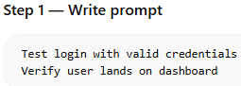
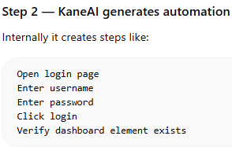
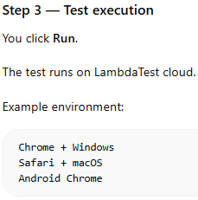
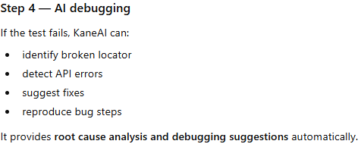
- kane-ai uses HyperExecute is a cloud-based test execution engine.
  - flow :
    - Test scripts → HyperExecute → executes tests in parallel → results

How KaneAI and HyperExecute Work Together?
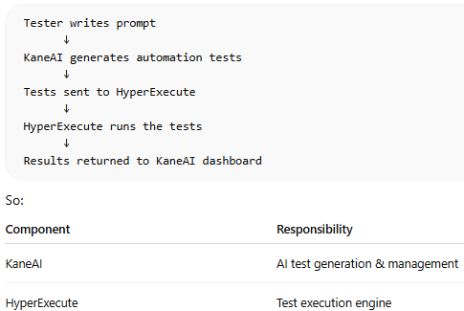

What HyperExecute Actually Runs?
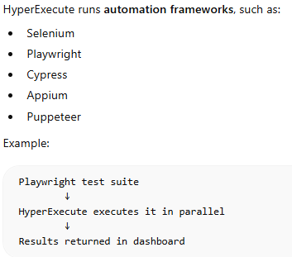

KANE-AI capabilities include:
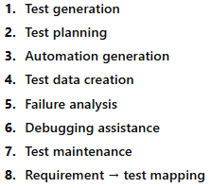
---------------------------------------------------------------------
  - Automation Code Generation :
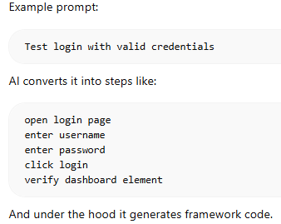
  - Test Data Generation :
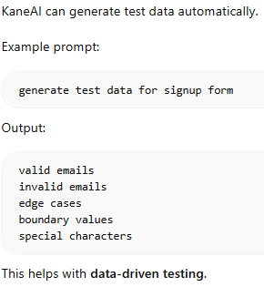
  - Failure Analysis
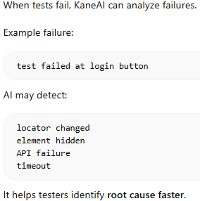

Correct Workflow of KaneAI
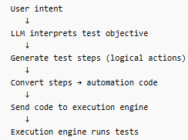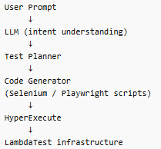

Simplified Architecture
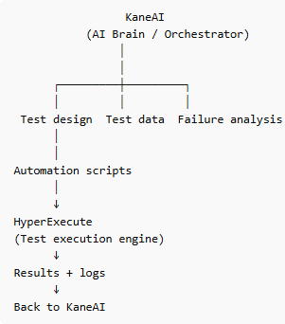

MCP Architecture
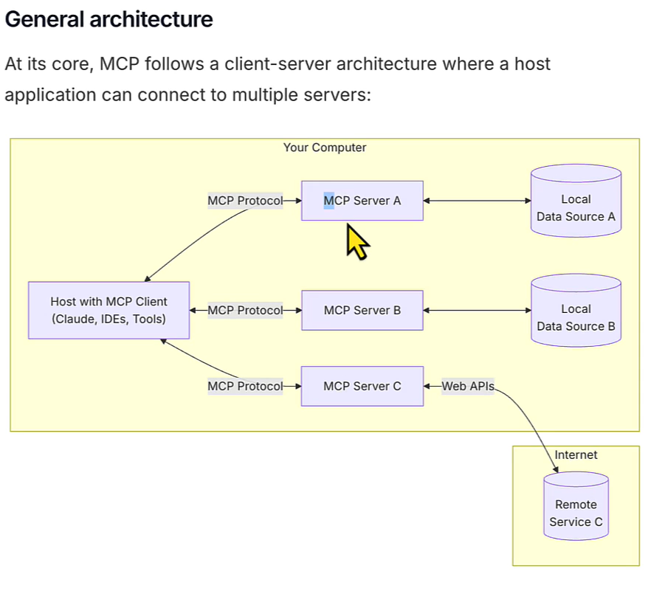

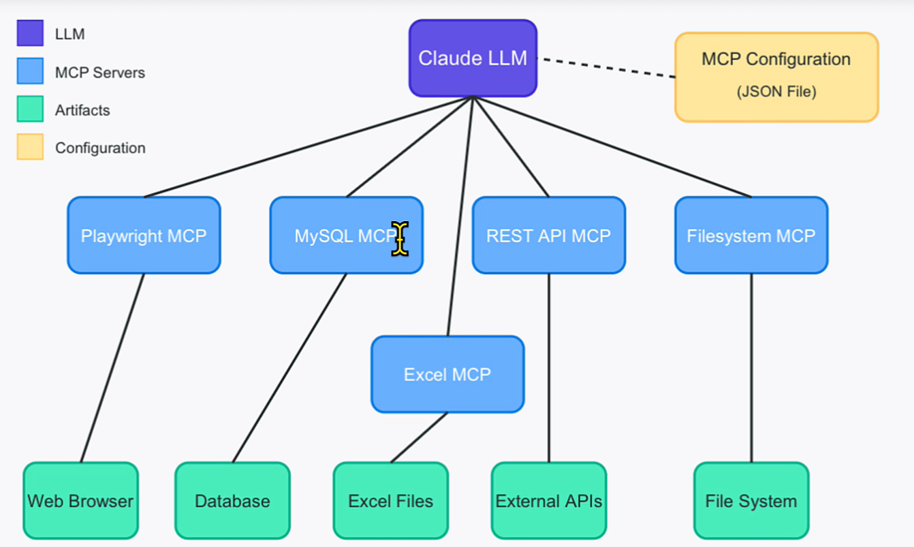

Testing AI itself (LLM)

Gen Ai Testing

What a Good Research Answer Looks Like
For building a GenAI-driven testing platform, frameworks like LangGraph, CrewAI, and AutoGen can be used to orchestrate AI agents responsible for test planning, generation, execution, and failure analysis. Among these, LangGraph appears most suitable due to its deterministic workflows and production readiness. For parallel agents execution RAY is the best suited tool.

Important Distinction
    - GenAI framework
        - LangGraph
        - CrewAI
        - AutoGen
      - Purpose
        - AI orchestration
    - Testing framework
        - Playwright
        - Selenium
      - Purpose
        - execute tests

Specialized Agents (Per Testing Type)
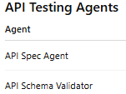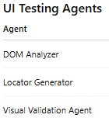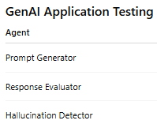

Agents workflow
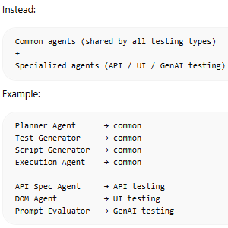

API Testing Workflow
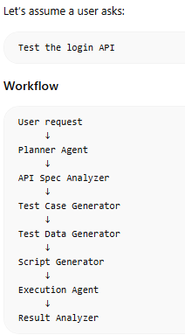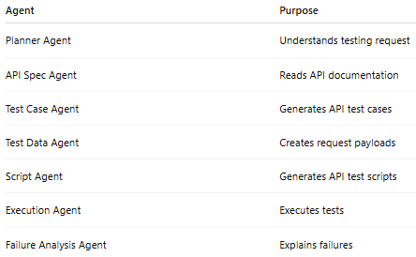

Example API Testing Flow

Step 1 — Planner Agent
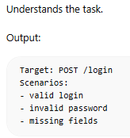

Step 2 — API Spec Agent
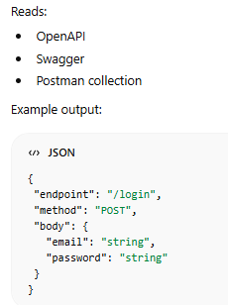

Step 3 — Test Case Agent
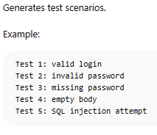

Step 4 — Test Data Agent
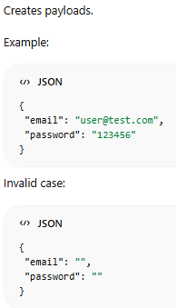

Step 5 — Script Generator Agent
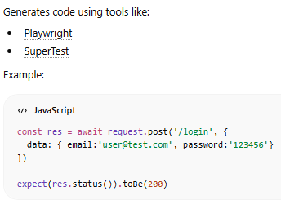

Step 6 — Execution Agent
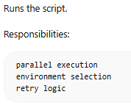

Step 7 — Failure Analysis Agent
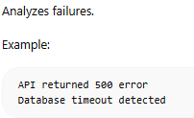

Biggest Challenges in GenAI Testing
- LLM hallucinations - AI may generate incorrect tests.
- Flaky tests - UI tests break due to timing issues.
- Test explosion - AI can generate too many tests.

Final System Architecture (API Testing Only)
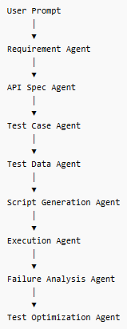

Categories of GenAI Frameworks
Category | Purpose | Example frameworks
LLM application frameworks | basic AI pipelines | LangChain, LlamaIndex
Agent orchestration frameworks | multi-agent systems | LangGraph, CrewAI
Autonomous agent frameworks | fully autonomous agents | AutoGen
Enterprise AI orchestration | scalable production systems | Semantic Kernel

Deep Analysis of Each Framework

1. LangChain
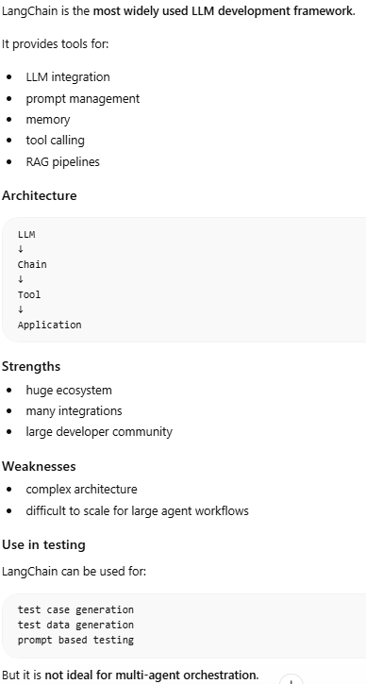

2. LangGraph – Best in all for agents ochestration
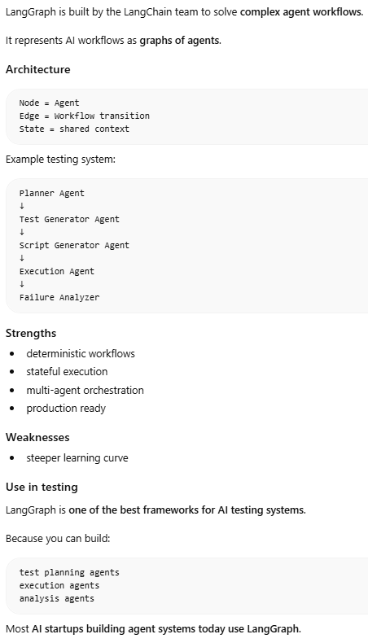

3. CrewAI (Best for structured role-based agents)
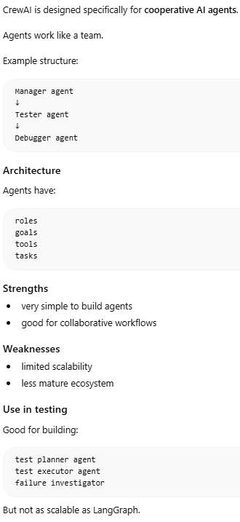

4. AutoGen (Best for research-style multi-agent collaboration)
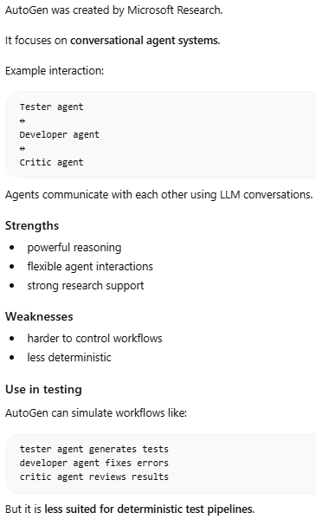

5. LlamaIndex
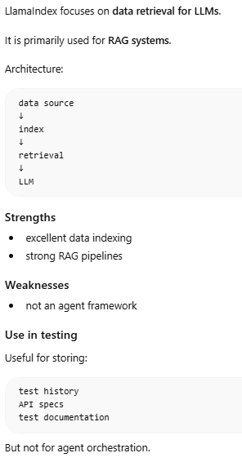

6. Semantic Kernel
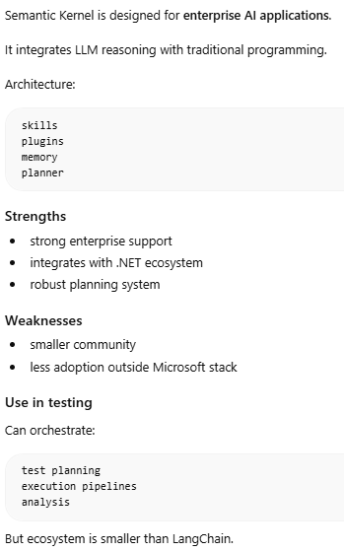

Recommended Architecture for AI Testing
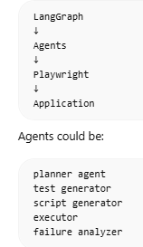

Typical LangGraph Multi-Agent Stack
- Agent orchestration – LangGraph
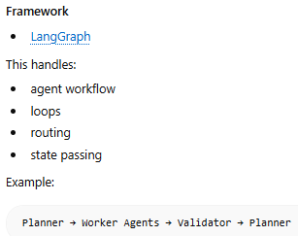
- LLM provider – OpenAi, Anthropic
- Memory layer
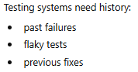
Common tools:
    - Redis → short-term state
    - PostgreSQL → structured storage
    - Pinecone → vector memory
    - Weaviate → semantic search
- Distributed execution – Ray
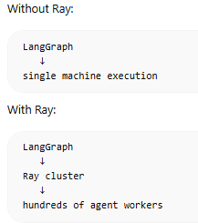
- Observability / debugging
  - Multi-agent systems break without monitoring
  - 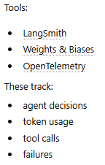

Example architecture for a serious multi-agent system
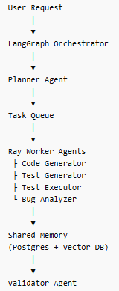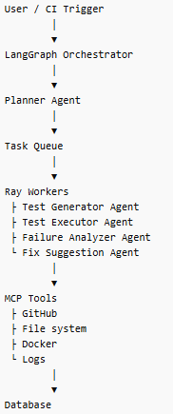

Combining LangGraph + AutoGen
